Hebrews 4:12-13;Acts 20:32;Deuteronomy 8:1-4 (The power of the Word to change us.)
A supernatural book of supernatural origin - Worldview and Bible study
1.God-
His existence
His revelation of Himself

2.Absolute truth- We must believe in this, as otherwise there will be nothing that makes sense: rationality itself will have been discarded.
Inspiration, infallibility, inerrancy

3.Miracles- Either God is Creator, omnipotent, and all wise in His deeds and revelation of Himself or He is not. We must take these things at face value rather than seeking to explain them in naturalistic terms, or rejecting them altogether.

4.Authority- We must submit to the Scriptures as the authority rather than sitting over it in judgment as though we know better than God. We cannot treat Scripture as any other book.

5.Consider the issues affected- Creation, judgment, flood, renewal, virgin conception and birth of Christ, predictive prophecy, resurrection of Jesus from the dead, and the second return of Jesus and attending miraculous events.
6. Recognize God’s right to give a deeper meaning that was not initially seen and understood by those writing the texts.Exodus 4:22;Hosea 11:1;Matthew 2:13-15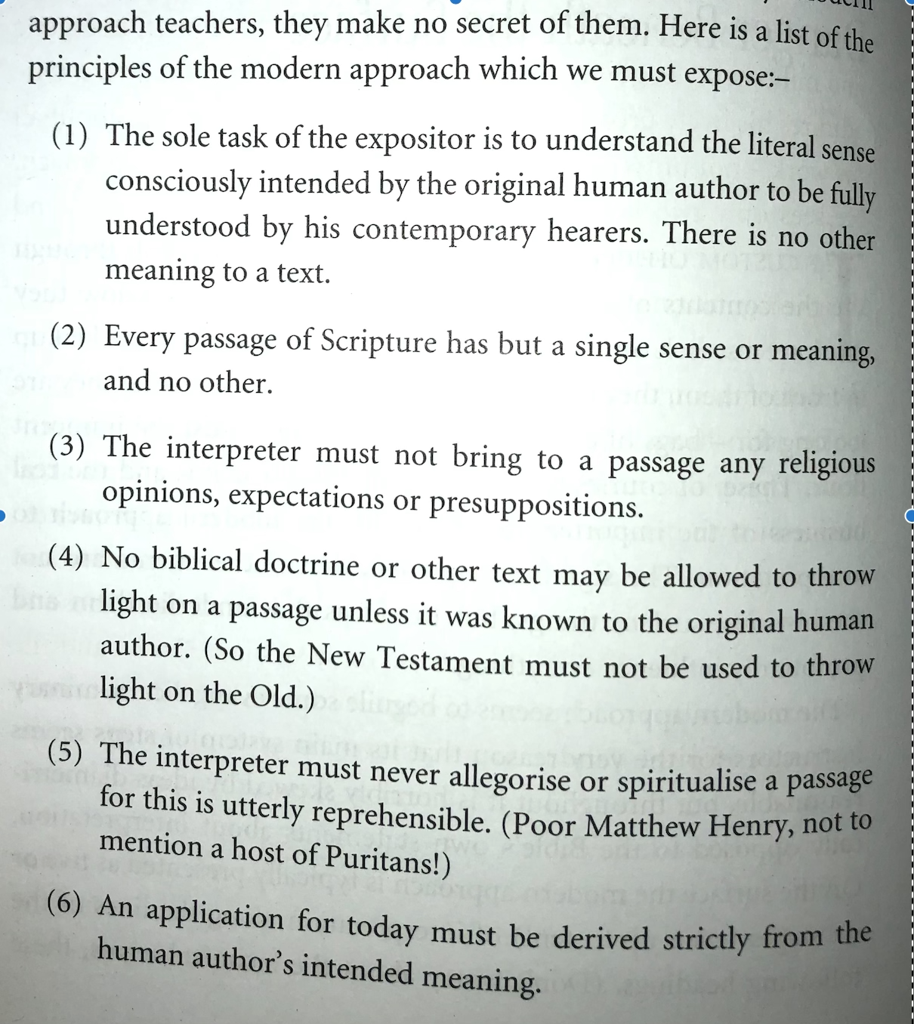

7. Realize that we must have presuppositions and/or expectations. Romans 15:4;1 Corinthians 10:1-12;2 Timothy 3:16-17

8. The analogy of faith. 1 Corinthians 2:12-13;Isaiah 28:9-13 Scripture interprets Scripture, thus we must look at our text within the context of the whole of Scriptural revelation.

